ECE103 HW#4 Oct. 22, 2018

[1]. 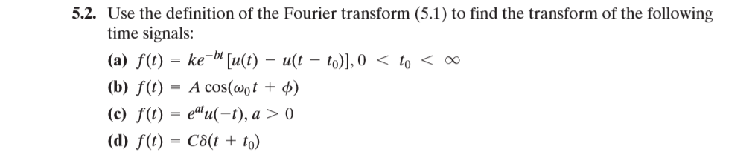

[2]. 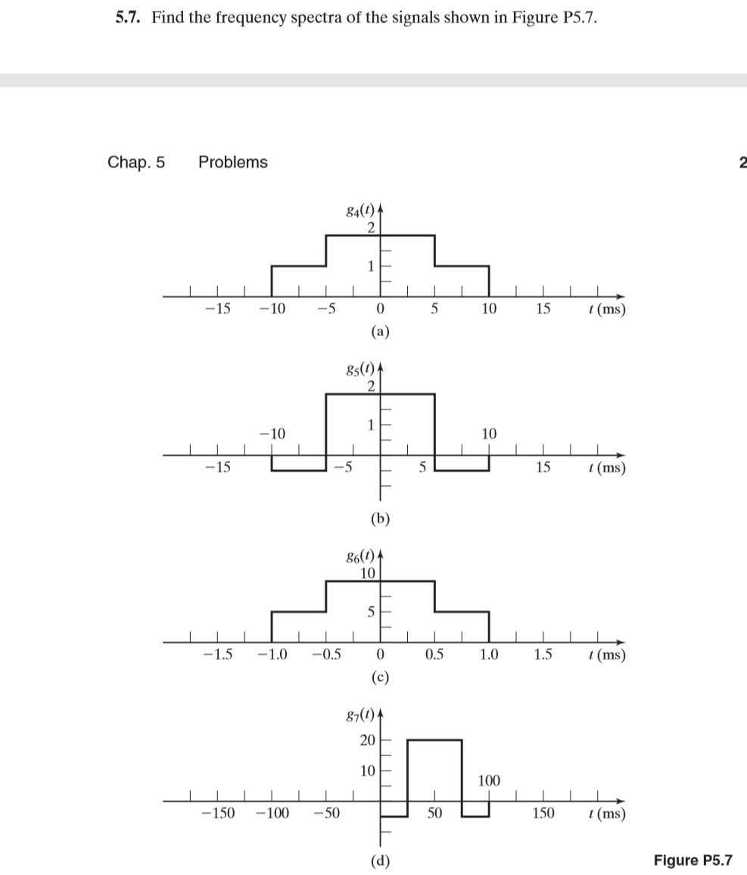

[3]. 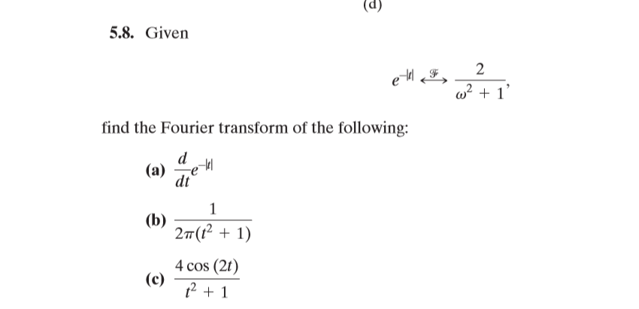

[4]. 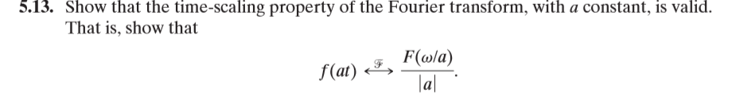

[5]. 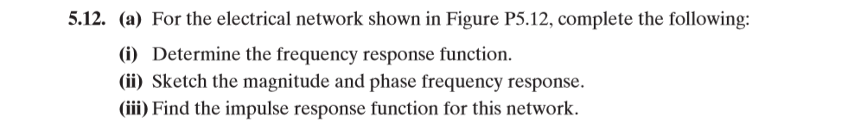



[6]. 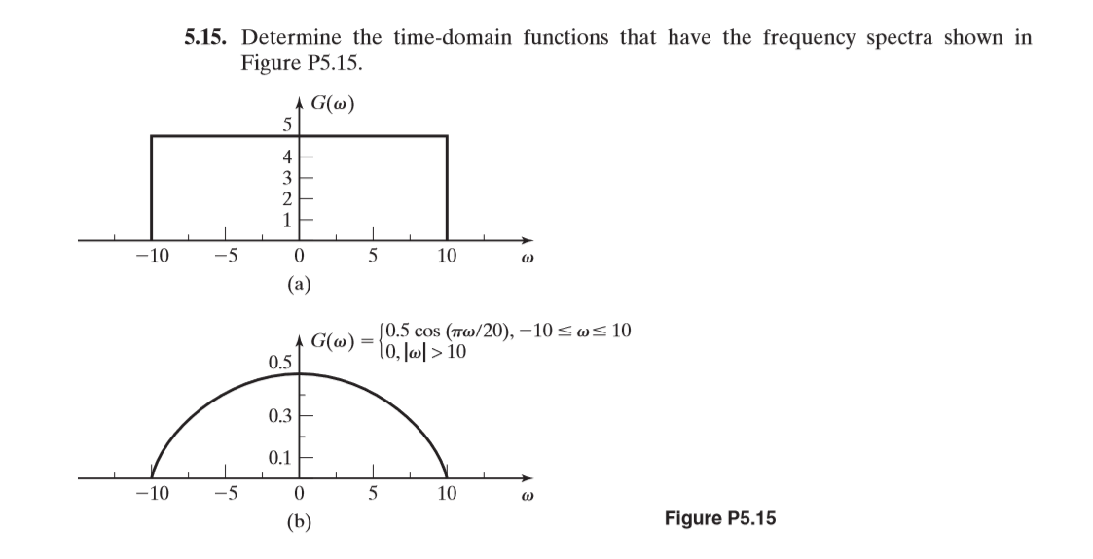

[7]. 